 | SAKR MANNING AGENCY  FOR RECRUITING EGYPTIAN LABOR ABROAD | Issue Date | 15.05.2022
 |  | Revision Date | 01.02.2024
 | Crewing Management Manual  Seafarer Employment Application | Revision | 1.3
 |  | Page | 4

Application For Position as | oiler/ ABLE Seafarer Engine
Register Code. | ER-3.030
Other Position (If Any)
Register Date | 03/07/2024
Last up Date Data | 25/February 2024
Expected Salary / Available Date | 1200$
1. PERSONAL DETAILS
Full Name | TAWFIK ADEL LOTFY JABALLAH
Date Of Birth | 11/January/1999 |  |  |  |  |  |  |  | Marital Status |  |  |  |  |  |  |  |  | Single ✓ |  |  |  |  |  | Married
Nationality | Egyptian |  |  |  |  |  |  |  | Height (Cm) |  |  |  |  |  |  |  |  | 165 |  |  |  | Weight (Kg) |  |  |  | 64
Place Of Birth | Cairo |  |  |  |  |  |  |  | Overall Size |  |  |  |  |  |  |  |  | L |  |  |  | Shirt Size |  |  |  | L
Nearest Port | Cairo Airport |  |  |  |  |  |  |  | Trouser Size |  |  |  |  |  |  |  |  | 32 |  |  |  | Shoes Size |  |  |  | 42
2. EDUCATION
College / School | graduated from the Marine Facilities Institute in Port Said 2019 with a grade of 93% excellence
Marline Test | Issued Date |  |  |  |  |  | Result % |  |  |  | Issued By (Authority) |  |  |  |  |  |  |  |  |  | Issued At
English Language | Fluent |  |  |  |  |  |  | Good ✓ |  |  |  |  |  |  |  |  | Average |  |  |  | Poor
……… Language |  |  |  |  |  |  |  |  |  |  |  |  |  |  |  |  | Average
 | Fluent |  |  |  |  |  |  | Good |  |  |  |  |  |  |  |  |  |  |  |  | Poor
3. CONTACT DETAILS
Home Address / City | 8 lotfy Mohamed JABALLAH / Cairo_ El Sahel
E-Mail | tawfikadel1999@gmail.com |  |  |  |  |  |  |  | M | +201069279670
4. TRAVEL DOCUMENTS º
Type | Document No. |  |  |  |  | ISS. Date |  |  | Exp. Date |  |  |  |  |  |  | ISS. By (Authority) |  |  |  |  |  |  |  | Place of Issue
Passport | A26411665 |  |  |  |  | 15/12/2019 |  |  | 14/12/2026 |  |  |  |  |  |  | Egyptian Authority
Seaman Book | S00026995 |  |  |  |  | 21/11/2022 |  |  | 19/11/2027 |  |  |  |  |  |  | EAMS |  |  |  |  |  |  |  | Alex.
Other Seaman Book
5. PROFESSIONAL QUALIFICATION / CERTIFICATE OF COMPETENCY
Certificate Name |  |  | Number |  |  | Issue Date |  |  |  |  |  | Expiry Date |  |  |  |  |  |  | Issued By |  |  |  |  |  | Issued At
COC ( Rank) ………….. |  |  |  |  |  |  |  |  |  |  |  |  |  |  |  |  |  |  | EAMS |  |  |  |  |  | Alex.
GOC |  |  |  |  |  |  |  |  |  |  |  |  |  |  |  |  |  |  | NTRA |  |  |  |  |  | Cairo
6. NEXT OF KIN / EMERGENCY CONTACT
Full Name |  | Adel lotfy Mohamed JABALLAH |  |  |  |  |  |  | Relationship |  |  |  |  |  |  |  | The father
Address / Country |  | 8 lotfy Mohamed JABALLAH/elsahel- Cairo
Tel. No./ Mobile |  | 01063180982 |  |  |  |  |  |  | Email
7. HEALTH CERTIFICATES & VACCINATIONS
Flag State |  | Number |  |  |  |  | Issue Date |  |  |  |  | Expiry Date |  |  |  |  |  |  |  | Issued By |  |  |  |  | Issued At
International Medical |  |  |  |  |  |  | 21/12/2023 |  |  |  |  | 20/12/2025 |  |  |  |  |  |  |  | EAMS |  |  |  |  | Alex.
Yellow Fever |  |  |  |  |  |  | 20/09/2020 |  |  |  |  | Forever |  |  |  |  |  |  |  | Ministry of Health |  |  |  |  | Alex
Cholera |  |  |  |  |  |  |  |  |  |  |  |  |  |  |  |  |  |  |  | Ministry of Health
Covid-19 |  | Vaccination Name |  |  |  |  | First Dose |  |  |  |  | Second Dose |  |  |  |  |  |  |  | (Other Does or Remarks)
 |  | Johnson and |  |  |  |  | 24/02/2022 |  |  |  |  | 09/11/2022
Johnson
- of 4 SMA/CMF/01

8. MARINE COURSES
Course Name | Number | Issue Date | Expiry Date | Issued By / At
Personal Survival Techniques | 24693/20/EG | 03/10/2020 | 30/09/2025 | AAST / Alex
Proficiency In Personal Survival Techniques
Fire Prevention and Fire Fighting | 24693/20/EG | 03/10/2020 | 30/09/2025 | AAST / Alex
Advanced Fire Prevention and Fire Fighting
Elementary First Aid | 24693/20/EG | 03/10/2020 | 30/09/2025 | AAST / Alex
Medical Care Studies
Personal Safety and Social Responsibilities | 24693/20/EG | 03/10/2020 | 30/09/2025 | AAST / Alex
Proficiency Of Security Awareness Training Seafarers | 24621/20/EG | 30/09/2020 | 27/09/2025 | AAST / Alex
Proficiency as a ship Security officer ( PSSO )
Proficiency In Survival Craft & Rescue Boats | 26325/21/EG | 05/08/2021 | 26/07/2026 | AAST / Alex
G.M.D.S.S
Communications
Advanced Communications
ECDIS Advanced Simulator (Management Level)
ECDIS Simulator (Operation Level)
Prevention and Combating of Marine Pollution
Radar & ARPA Simulator and Search &rescue ARPA Simulator and Search
Marine Radar and automatic Radar Plotting
Bridge resource Management (B.R.M)
Engine resource Management (E.R.M)
Navigational Watch keeping
Proficiency for Rating forming part of Navigational watch (II/4) |  |  |  | EAMS / Alex.
High voltage training – operation of ship (1000 Volt and More)
Passenger Safety Cargo Safety and Hull integrity | 5705/23/EG | 28/02/2023 | 07/02/2028 | AAST / Alex
Crowd Management Training | 5691/23/EG | 28/02/2023 | 04/02/2028 | AAST / Alex
Crisis Management and Human Behavior Training | 5719/23/EG | 28/02/2023 | 08/02/2028 | AAST / Alex
Safety training for Personal Prov. Direct Passengers | 5677/23/EG | 22/02/2023 | 06/02/2028 | AAST / Alex
Practical Ability to Prepare Meals and (MLC 2006)
Personal Hygiene and Envir. Protection (MLC 2006)
Safety and Health in the Provision Meals (MLC 2006)
Food Storage and inventory Control (MLC 2006)
Ships Cook Certificate (MLC 2006) |  |  |  | EAMS / Alex.
Abel Seafarer Deck
Proficiency for Abel Seafarer Deck ( II/5 ) |  |  |  | EAMS / Alex.
Engineering Watch keeping | 26362/20/EG | 15/10/2020 | ------ | EAMS / Alex.
Proficiency for Rating forming part of a watch in engine room | 00538 | 14/07/2021 | ------ | EAMS / Alex
Abel Seafarer Engine | 34536/22/EG | 14/11/2024 | ------ | EAMS / Alex
Proficiency for Abel Seafarer Engine ( III/5 ) | 00342 | 30/11/20222 | ------ | EAMS / Alex.
Electro Technical Rating
Proficiency for Electro Technical rating ( III/7 ) |  |  |  | EAMS / Alex.
D.p. induction/ d.p. advanced
D.p. operator (unlimited)
Others

- of 4 SMA/CMF/01

 |  |  |  |  | 9 - COMPLETE SEA – SERVICE DETAILS
Name: |  |  |  |  | Rank: |  | Register Code:
Company N | ame | Rank | Vessel  Name/IMO  Number | Flag | Signed On | Signed Off | Period | Vessel Type | D.W.T./ G.R.T | Engine Type | BH/ KW | Reason for Sign off
Sonar Shipp | ing | Oiler | Samir/9235854 | Panama | 16/03/2023 | 14/12/2023 | 9 month | Bulk carrier | 52510 / 29885 | Mitsubishi | 11217/ 8250 | My contract expires
Alex marin | e | Oiler | Joy m/8902931 | Panama | 10/08/2021 | 23/10/2022 | 14 month | Bulk carrier | 13759 / 9815 | Man B & W | 5180 / 3810 | My contract expires
Lara Shippi | ng | Oiler | Safia /8404460 | Togo | 22/11/2020 | 03/06/2021 | 6 month | General cargo | 4950 / 2920 | Mak 8M | 2370 / 1765 | My contract expires
- of 4 SMA/CMF/01

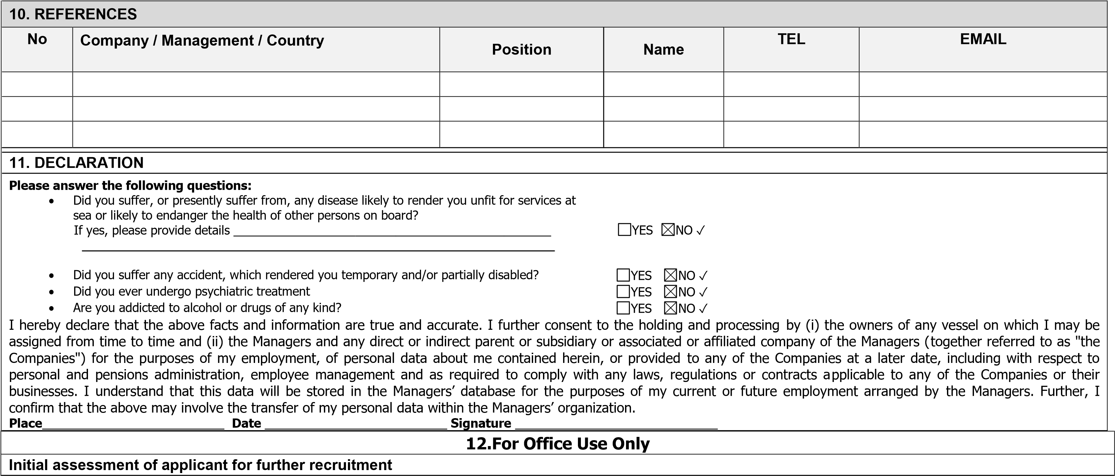
Comments
Responsible person
Name / Signature _______________________________________________ Date ________________________________
- of 4 SMA/CMF/01

